# NOTICE OF PUBLIC HEARING CITY OF BAINBRIDGE ISLAND HEARING EXAMINER

**Madison Grove Preliminary Subdivision**

**City File No. PLN50667 SUB**

YOU ARE HEREBY NOTIFIED that the City of Bainbridge Island Hearing Examiner will conduct a public hearing at 10:00 AM on Friday, April 20, 2018, in the Council Chamber, City Hall, 280 Madison Ave N, Bainbridge Island, Washington, pursuant to the provisions of BIMC 2.16.010, 2.16.100 and 2.16.125.

**Applicant:** Gary and Susan Ohrt

**Description of Proposal:** Preliminary subdivision of three lots into eight

**Location:** 997 Madison Avenue North

**Tax Account Number:** 272502-1-126-2001; 272502-1-140-2003; 272502-1-141-2002

YOU ARE INVITED to attend the hearing and make oral and written comments. The Hearing Examiner has discretion to admit exhibits, to set time limits, and to limit testimony to relevant, non-repetitive comments. If you are unable to attend, written comments, photographs or other exhibits on the application may be submitted until the close of the hearing. All such submissions should reference the City File Number above and be directed to the Hearing Examiner Assistant at City Hall.

The State Environmental Policies Act (SEPA) determination was issued on March 22, 2018. The appeal period ends on April 5, 2018. Any appeals of this determination may be heard during the public hearing.

QUESTIONS may be directed to the Department of Planning and Community Development, to the attention of Kelly Tayara, Associate Planner, at [pcd@ci.bainbridge-isl.wa.us](mailto:pcd@ci.bainbridge-isl.wa.us) or 206.780.3787.

CITY OF BAINBRIDGE ISLAND

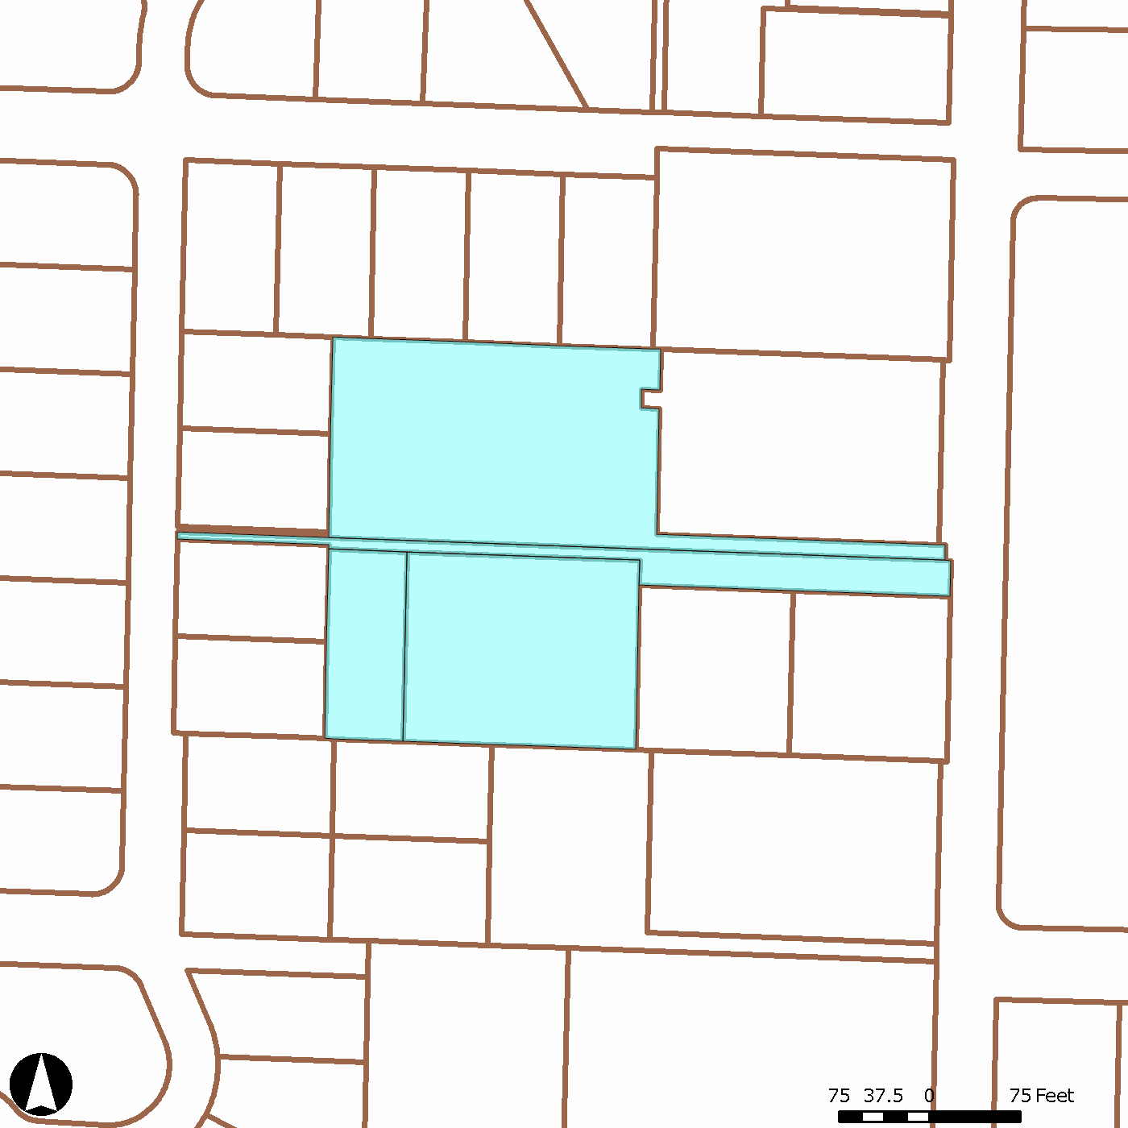

Date of Publication: March 30, 2018

Madison Avenue

Duane Lane

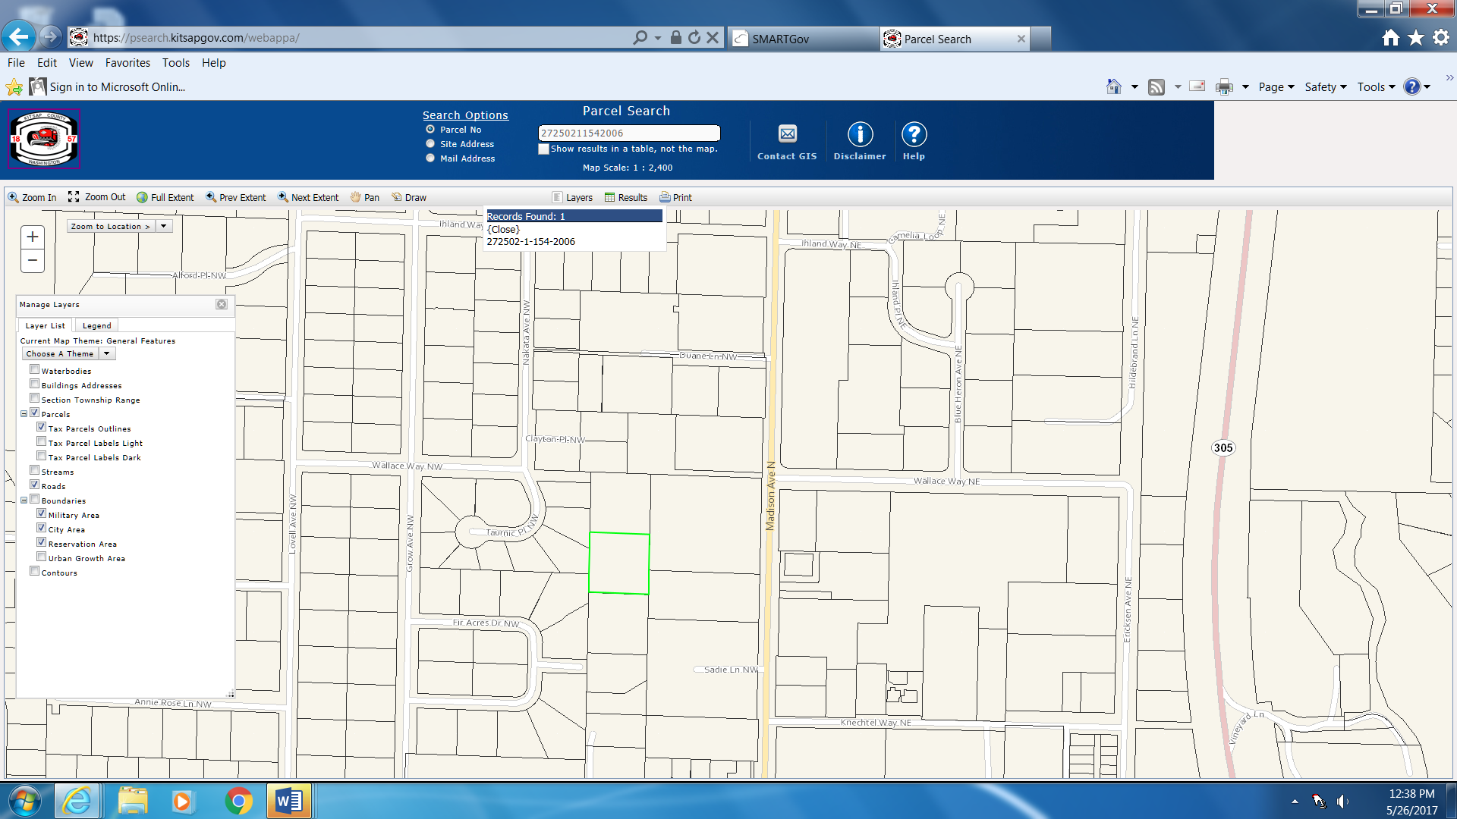

Vicinity Map