Department of Planning and Community Development

Staff Recommendation
Date: March 17, 2017
To: City of Bainbridge Island Planning Commission
From: Joshua Machen, AICP, Planning Manager
Gary R. Christensen, AICP, Director
Project: Madrona School
File No: PLN 18970B SPR / CUP

Applicant: Madrona School
219 Madison Avenue S.
Bainbridge Island, WA 98110
Request: Construction of a new PK-8 private school, which includes classrooms, offices, and a gymnasium/auditorium. Site improvements include 39+ parking spaces, play field, stormwater facilities and on-site septic system. An existing residence, barn and two sheds will be demolished (Reference Documents A, B, & C)
Location: 11478 N. Madison Avenue NE
Consolidated Project Review:
In accordance with regulations contained in BIMC 2.16.170, an applicant for a single project proposal requiring more than one of the land use applications identified in BIMC 2.16.010 may be processed under the consolidated project review process. The applicant requests consolidated review of the applications for Site Plan and Design Review and Conditional Use Permit.
Public Notice / Environmental Review:
The first pre-application conference was held on October 8, 2013. No formal plans had been developed, so the discussion was generally about zoning and the process. A second pre-application conference was held on July 19, 2016. A public participation meeting was held on July 18th, 2016. Applications for Site Plan Review and Conditional Use Permit were received on August 2, 2016.
After deeming the application complete the City determined that the project is subject to State Environmental Policy Act (SEPA) review as provided in Washington Administrative Code (WAC 197-11-800). Utilizing the optional DNS process provided in WAC 197-11-355, the City issued a combined Notice of Application/SEPA comment period on October 14, 2016 (Reference Document D). The 14-day comment period ended on October 28, 2016; public comment is discussed in Section I.C. of this report. The City, acting as lead agency, issued a SEPA threshold determination for this proposal on February 27, 2017 (Reference Document E). No appeals were filed.
Planning Commission Review:
The Planning Commission shall provide a recommendation to the Hearing Examiner pursuant to BIMC 2.14.020, BIMC 2.16.040.C.2, and BIMC 2.16.110.C.
Recommendation:
Approval of the request subject to the following conditions:

SEPA Conditions
- To avoid impacts to vegetation, no construction activity shall occur in landscape buffers or within the critical root zone of significant trees within landscape buffers, including staging, storage, materials laydown, parking, construction vehicle turnaround, or equipment.
- Prior to clearing permit or construction permit issuance, fencing shall be erected and posted with signage to protect areas of prohibited disturbance. Signs shall be affixed to the fence every 50 feet indicating the protected area. Fencing shall remain in place until construction is complete, and removal shall be subject to approval of the Planning Division. No construction activities, including grading and/or vegetation removal, shall occur prior ‘area of disturbance’ plan approval, and inspection and approval of the fencing installation, by the Planning Division.
- Temporary chain link fence a minimum five feet in height with tubular steel poles or “T” posts shall delineate the area of prohibited disturbance in the following locations:
a. At the edge of the drip line of trees proposed to be preserved between N. Madison Avenue and the proposed access drive. Special care shall be taken to protect the significant trees, vegetation, and rain garden area adjacent to the driveway.
b. Along the buffer adjacent to the north property line.
- Orange plastic fencing shall delineate the perimeter buffer where chain link fencing is not required and where existing vegetation is being preserved to meet the buffer requirement.
- All graded materials removed from the subject property shall be hauled to and deposited at City approved locations (Note: local regulations require that a grade/fill permit is obtained for any grading or filling of 50 cubic yards of material or more if the grading or filling occurs on sites that have not been previously approved for such activities. A SEPA Threshold Determination is required for any fill over 100 cubic yards on sites that have not been previously received a SEPA determination).
- Contractor is required to stop work if any historical or archaeological artifacts are uncovered during excavation or construction and immediately notify the Department of Planning and Community Development and the Washington State Office of Archaeology and Historic Preservation.
- To mitigate the possible impact on adjacent properties from light and glare, all exterior lighting shall be hooded and shielded so that the bulb is not visible from adjacent properties. All landscape lighting shall be downcast and lighting within surface parking lots shall be no higher than 5 feet above grade. All exterior lighting shall comply with BIMC Chapter 15.34.
- All on-site stormwater facilities shall remain privately owned and maintained. The owner shall be responsible for maintenance of the storm drainage facilities for this development following construction. Annual inspection and maintenance reports shall be provided to the City. A Declaration of Covenant for stormwater system operation and maintenance will be required to be recorded before issuance of occupancy permits. The approved language for the Declaration of Covenant is found in BIMC 15.21 Exhibit A.
- Stormwater detained in the proposed detention pond will be released at a controlled rate through a control structure and ultimately out through a dispersion tee located within 25 feet of the north-eastern property line. The nearest residence downgradient of the dispersion tee is within 50 feet. The release of stormwater from the detention pond shall be monitored for a minimum of 5 years to ensure proper function of pond and control structure and to ensure stormwater release is not detrimental to the neighboring property or structures. The monitoring plan shall be developed by the project stormwater engineer, reviewed and approved by the city, and included with the overall stormwater operation and maintenance plan developed under condition number 1 above.
- The applicant shall be responsible for verifying water pressure and fire flows are adequate from connections to water mains.
- All construction activities shall comply with the construction operating hours limitations contained in BIMC Chapter 16.16.
- Noise produced by this development must comply with the maximum environmental noise levels established by the Washington Administrative Code 173-60 or its successor.

Project Conditions
- To ensure the Madrona School facility remains compatible with the surrounding neighborhood, the school is limited to an occupancy of 200 students and 27 teachers for standard school days (this limitation does not apply to special events or functions).
- To ensure historic and cultural resource preservation, a completed Washington State Historic Property Inventory Field Form shall be recorded with the State Department of Archeology and Historic Preservation prior to the demolition of the historic home on the property.
- A NPDES permit from the Department of Ecology will be required prior to ground disturbing activities.
- A Right-of-Way permit will be required prior to any work within the right of way. The ROW permit will be subject to separate conditions and bonding requirements.
- Except for modifications reflecting compliance with these conditions of approval, building plans shall substantially conform to plans submitted on August 2, 2016, except as follows: Sheet A-1.00 submitted on September 12, 2016; Sheet C1-C3 submitted on January 10, 2017.
- Prior to any construction activities, the applicant shall obtain the appropriate permits from the City of Bainbridge Island, including but not limited to clearing, grading, and/or building permits.

- The project shall comply with the following conditions of the Fire Marshal:
- The project shall comply with all applicable provisions of the adopted Fire Code.
- All driving lanes within the project are considered Fire Lanes and shall be labeled as such as directed by the Fire Marshal.
- Landscaping shall not impede access of fire department apparatus and personnel.
- Prior to building permit issuance a Boundary Line Adjustment shall be submitted and approved. The structures on any resultant lot must meet zoning requirements.
- A minimum of nine bicycle spaces must be provided. Bicycle facilities shall allow secure locking of both the frame and wheels of a bicycle.
- In order to screen the proposed school from the adjacent single-family home to the south, a six-foot high solid wood fence shall be erected along the property line adjacent to the parking lot and play field prior to final inspection of the first phase of the project. (Note: this condition may be waived upon written request from the property owner to the south).
- All perimeter buffers shall be planted to the full screen landscape requirements in accordance with the submitted landscaping plan during the first planting season following the grading and access construction phase.
- Landscape buffers shall be maintained for the life of the project.
- New plantings shall be the following heights at time of planting: Evergreen trees shall be not less than six feet in height; Deciduous trees shall be not less than two-inch (caliper in diameter?) dbh; Evergreen shrubs shall be not less than 18 inches in height.
- All plantings shall be installed or installation financially assured in accordance with BIMC 18.15.010.H. prior to occupancy of any of the new buildings. Subsequent to installation approval by the Department, maintenance assurity shall be required in accordance with BIMC 18.15.010.H.
- The primary internal walkways shall be surfaced with nonskid hard surfaces (asphalt pavement or concrete), meet handicapped-accessibility requirements and be designed to provide a minimum of five feet of unobstructed width.
- The walkway adjacent to the pick-up / drop-off lane shall be curbed and raised six inches above adjacent vehicular surface grade, except where required to meet accessibility standards.
- Raised curbs shall be used to define driveways from the public right-of-way, landscape areas within the parking lot, the ends of parking aisles, and the vehicular circulation pattern.
- No parking or pick-up/drop-off shall occur on Madison Avenue or Windsong Loop.
- Outdoor trash / recycle receptacles shall be enclosed with a solid structure / gated and screened from view with evergreen vegetation.
- No high field lights are allowed for the school.
- The project is allowed one sign at the entrance to the school. The sign shall be located outside of the public right-of-way and not exceed 10 square feet in size and shall be constructed of natural materials. The height of the sign shall not exceed five feet from existing grade.
- Prior to building permit issuance of any phase, an approved building site application for on-site septic system and water availability shall be obtained from the Kitsap Public Health District.
- Prior to building permit issuance, the landowner must record a notice on title listing these conditions of approval with the Kitsap County Auditor.

______________________________________________________________________________________
Staff Analysis
I. Findings of Fact
A. Site Characteristics
1. Tax Assessor Information:
a. Tax Lot Numbers: 112502-3-099-2008
112502-3-102-2003
112502-3-1003-2005
112502-3-001-2004
b. Owner of record: Center Tree LLC
c. Lot size: the total of the four lots is 4.79 acres
d. Existing land use: Single -family residence and associated outbuildings.
2. Background
The Madrona School is a non-profit private school that is currently located in the congregational church in downtown Winslow. The school is proposing to relocate to the North Madison Avenue property to accommodate their increase in student population and to address learning needs that their own campus can provide that the constrained property in Winslow can’t provide. The proposed school is designed to accommodate up to 200 students and 27 teachers and administration personnel.
The proposed school is proposed to be developed in three phases as follows:
Phase 1: Grades 1-8, Administrative Offices
Nine classrooms and four offices -11,000 square feet on two levels
Phase 2: Early Childhood
Four classrooms -5,000 square feet on two levels
Phase 3: Gymnasium/Auditorium
GYM, three classrooms, kitchen, and apartment- 10,000 square feet on two levels
The existing house on the site will be demolished with the construction of Phase 3. No off-site road construction is proposed, other than entry and exit drive aprons connecting to N. Madison Avenue NE.

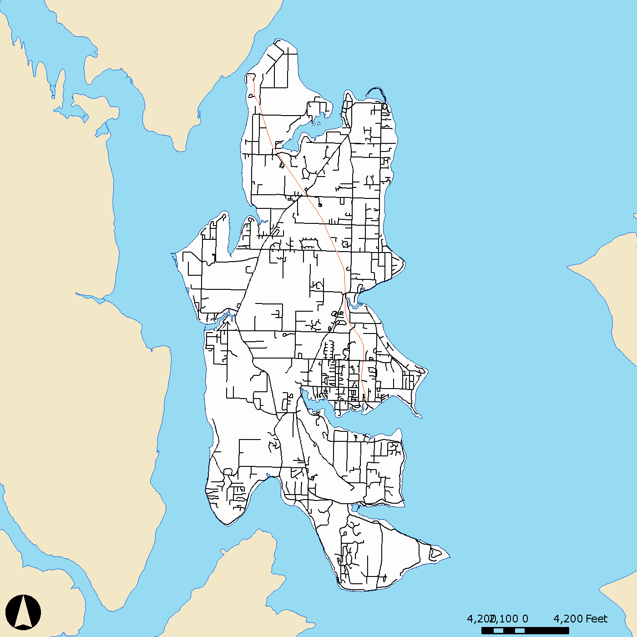
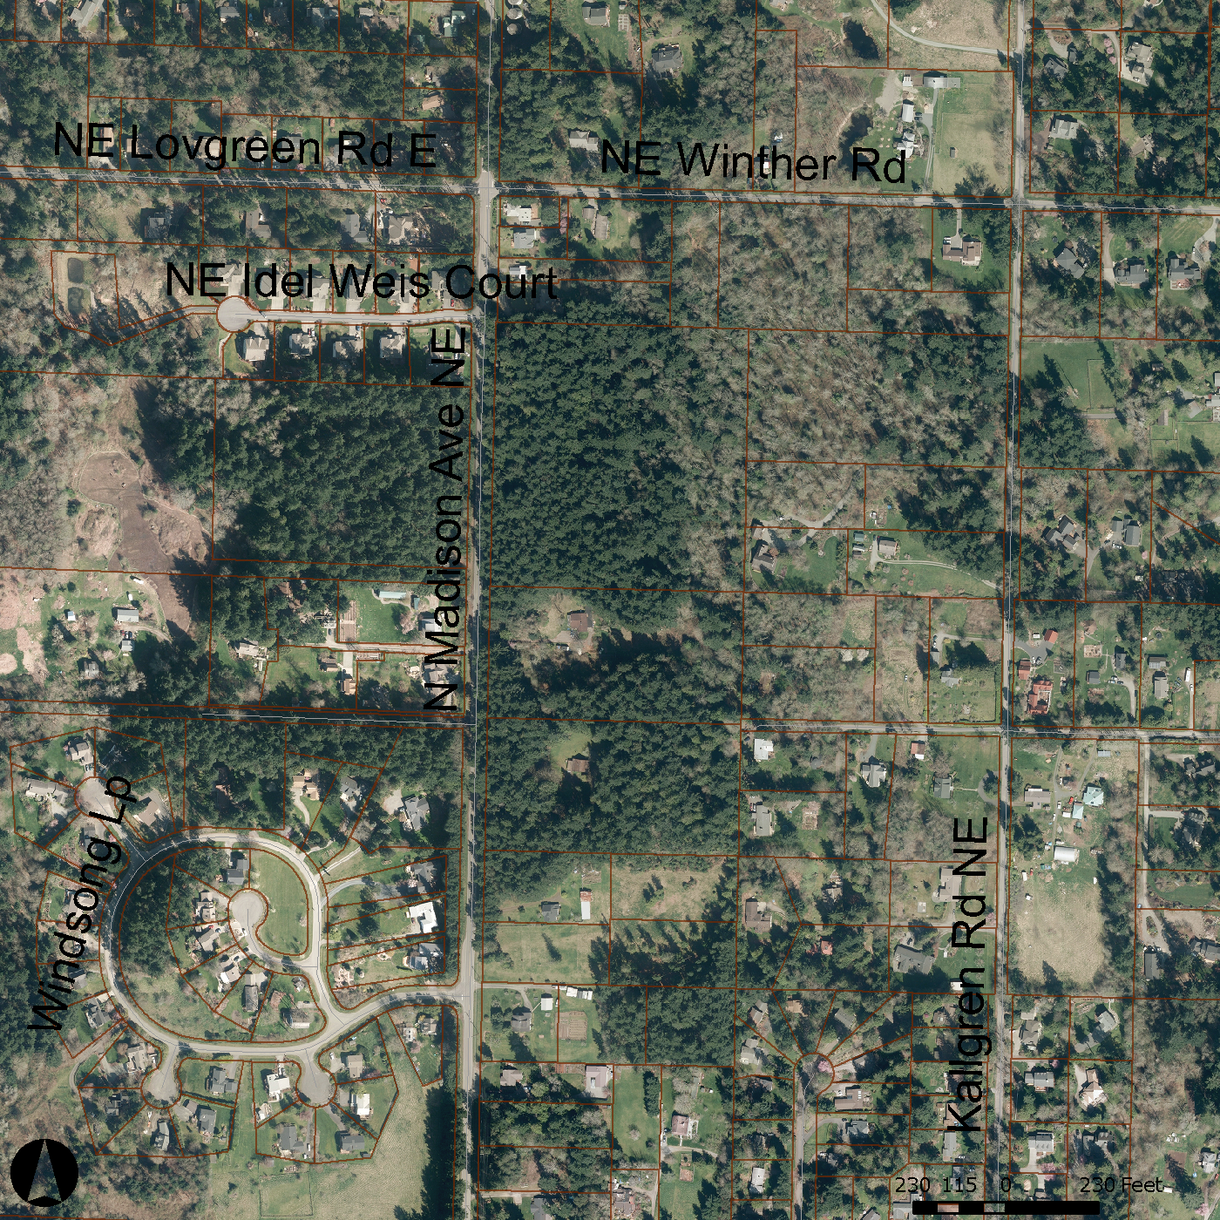

Vicinity Map

Project Site
Zoning
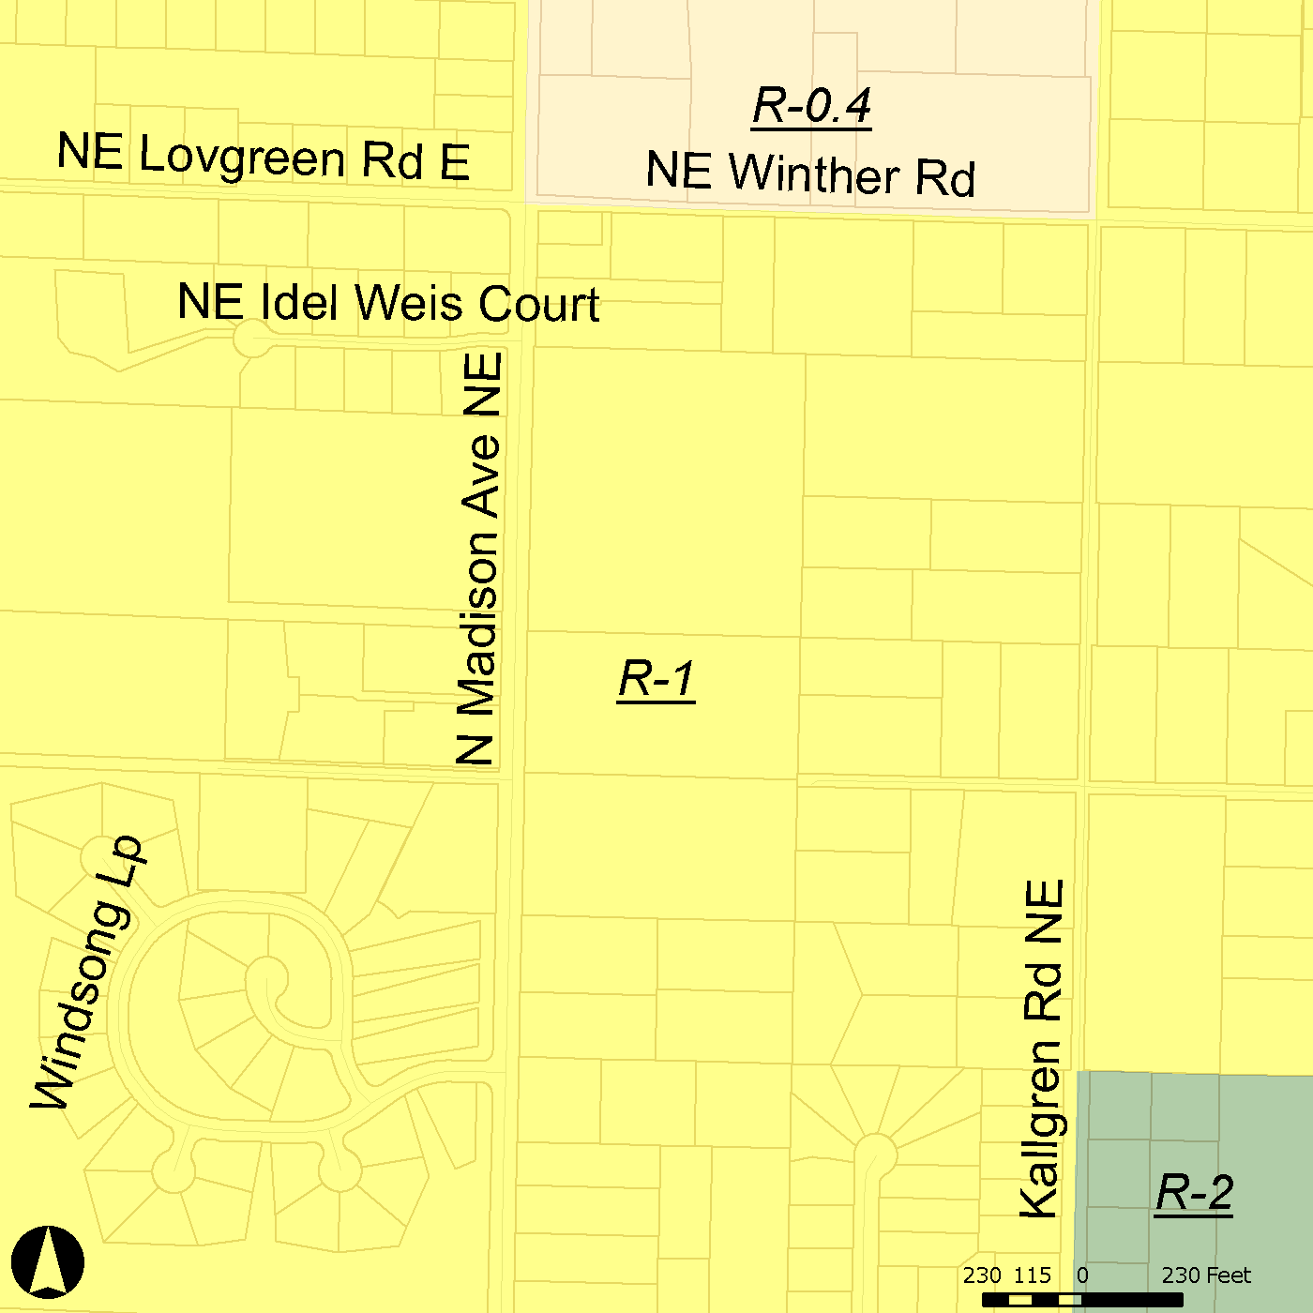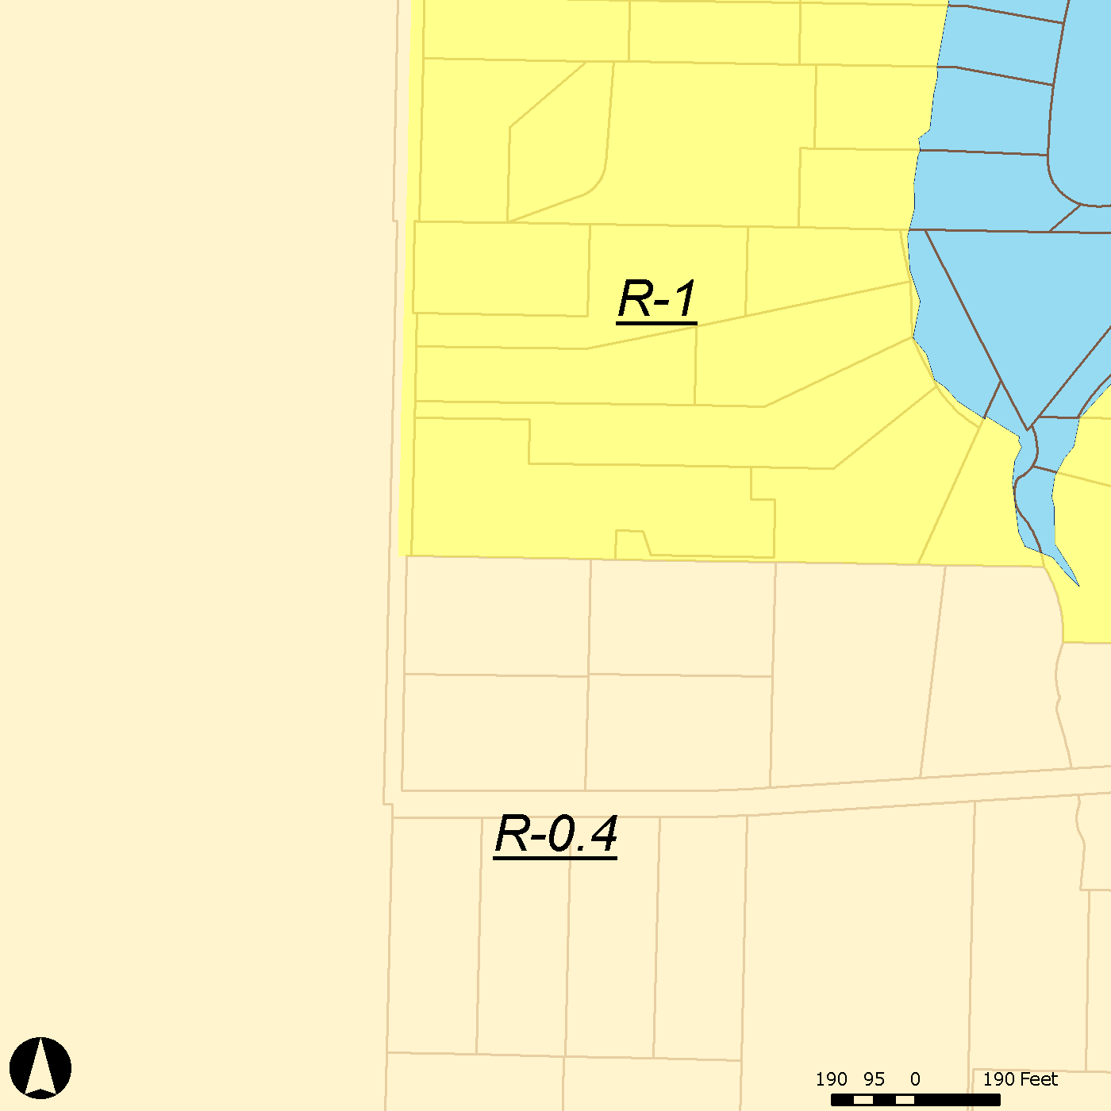

3. Zoning and Comprehensive Plan Designation: The subject property is within the R-1 district and the Open Space Residential (OSR-1) designation. All the surrounding properties are also zoned R-1 and the Comprehensive Plan Designation is OSR-1.
4. Existing Development: The property contains an existing single-family residence and accessory buildings. The surrounding properties are either developed with single-family homes or are currently undeveloped.
5. Access: Vehicular access is provided from N. Madison Avenue NE.
6. Soils and Terrain:
Site soils are composed of Harstine and Ragnar gravelly/sandy loams. Much of the site is cleared pasture/grass area with a perimeter buffer of trees around the property except the southwest portion of the site which is cleared pasture area adjacent to the adjoining property’s access driveway and garage/outbuilding.
The topography of the site is generally flat in the middle with a gradual slope to the southwest and southeast.
7. Public Services and Utilities:
  - Police: City of Bainbridge Island Police Department
  - Fire: Bainbridge Island Fire District
  - Water: On-site Well
  - Sewer / Septic: On-site Septic
  - Storm drainage: On-site detention and dispersion is proposed for the east side of the site, and on-site detention for the west side.
B. Comprehensive Plan Goals and Policies
1. Land Use Element
- Historic Preservation - Goal 3
Archaeological resources should be identified, preserved, and / or left undisturbed.
The site contains a historic home that the City has found to be eligible for the local register. The applicant has indicated they intend to maintain the house during the first two phases of construction, but that the house is not in a condition to be preserved into the future and would be demolished during the third phase. To ensure historic and cultural resource preservation, a completed Washington State Historic Property Inventory Field Form shall be recorded with the State Department of Archeology and Historic Preservation prior to the demolition of the historic home on the property (Condition 14).
Should any historical or archaeological artifacts be uncovered during excavation or construction, project work must stop and the applicant must notify the Department of Planning and Community Development and the Washington State Office of Archeology and Historic Preservation. (Condition 6)
2. Economic Element
a. Economic Element - Goal 1
Retain and enhance a diversified local economy. The City should embrace diverse and innovative business opportunities compatible with the community and develop programs to make Bainbridge Island an attractive location for those businesses.
The development provides for a private not-for-profit elementary and pre-school educational facility.
3. Cultural Element
a. Arts Education - Goal 2
Demonstrate commitment to quality arts education and lifelong learning by advocating for comprehensive inclusion of the arts in our schools and community settings. Support a comprehensive quality arts education program in the schools and the community.
The development provides for a learning environment that emphasis the natural environment and the arts.
b. Humanities - Goal 7
Foster the spirit of community in which the richness of human experience is explored and nurtured through ongoing analysis and exchange of ideas about the relation to self, others and the natural world.
The school relies on the natural environment to address Waldorf education principles and methods. The Waldorf program provides a broad curriculum, including academics, art and music education, physical education, and emotional and social education.
The project emphasizes outdoor spaces and the discovery of the natural world. For example: The proposed development provides playgrounds with all-natural materials, a campus with trails through a natural environment. Buildings are oriented to capture natural light and to fit into the natural topography of the land avoiding competition with the natural setting.
C. Public / Agency Comment
Multiple public comments were received. The comments are summarized as follows:
- Neighborhood/Zoning Compatibility:
Several public comments were received regarding the scale of the proposed development and the structures are too large and non-compatible with the existing residential neighborhood character. The school does represent a distinct change from the single-family homes within the immediate vicinity. The property upon which the school is proposed is 4.79 acres in total which under current zoning could support up to five single-family residences each with an accessory dwelling unit and associated out buildings. Under the conditional use permit requirements, the allowed lot coverage (the area of the lot allowed to be covered by buildings) is limited to half the amount that would be allowed if single-family homes and accessory structures were proposed on this same site.

Multiple comments suggested that the zoning should not allow a use that is like a commercial development and questioned why private schools are allowed in a residential zone. The zoning for the subject property is R-1, Residential one unit per acre zone. However, the R-1 zone allows schools (public or private) under the provisions of obtaining a conditional use permit. Washington State laws grant local jurisdictions (i.e., city) land use regulatory authority. The elected City Officials of Bainbridge Island have adopted zoning definitions for commercial and educational development and adopted zoning regulations as to where these uses may be allowed, or allowed through a conditional use permit. Educational facilities are an allowed use in the R-1 zone through the issuance of a conditional use permit.
- Traffic and vehicular trips:
Several public comments expressed concern regarding the number of vehicular trips proposed to the subject property each day and the impact those trips may have on adjacent roadways and transportation systems. The school facility poses a significant increase in vehicular trips per day when compared to single-family homes. The submitted traffic study indicates the school at full capacity is expected to generate 720 daily trips, 360 in and 360 out. Educational facilities requiring a conditional use permit and must be located on roads classified as residential suburban, collector, or arterial on the Bainbridge Island functional road classification map. N. Madison Avenue NE is listed as an arterial road on the classification map. Two traffic studies were performed to address the issue of traffic generation and the impact that the proposed development would have on surrounding roadways. Typically, traffic calculations look at the PM peak hour because that is the hour of highest congestion. The proposed development’s typical traffic patterns fall outside of this peak hour, so the school is likely to have little to no impacts on the PM peak hour. However, in consideration of public comments received a second traffic study was performed to analyze the morning peak hour and specifically the potential impact on the Sportsman’s Club/SR305 intersection (Reference Document H). The traffic studies indicate that this intersection will fail in the year 2040 with or without the proposed school. The City has generally accepted that improvements at major intersections that serve large populations of the island are a City and State responsibility and that individual project are not expected to make the improvements when their portion of the impact is very minimal.
- Noise from children:
Only a couple of public comments expressed concern regarding noise emanating from children’s play. While many of the surrounding properties are developed with single-family homes, only one is in proximity to the playfield to be impacted by noise from children’s play. The closest house is approximately 75 feet away from the property line and the proposed playfields would be over 100 feet from the residence and will have a new 15-foot landscape buffer and possible fence between the properties. In accordance with a recent City of Bainbridge Island Hearing Examiner Decision and Analysis on the Montessori Country School, noise from children (unamplified human noise) is exempt from noise standards of the Municipal Code or state law. In that same decision, the examiner referred to a noise study at an existing school of 400 students and the noise from an active play area at 25 feet was 60-64 dBA. Since the nearest existing house is over 100 feet away and will be screened with vegetation and a fence, it is likely that the noise would be significantly diminished not having an adverse impact on the neighbor.
- Visual impact:
A few public comments received expressed concern that the proposed school would have a negative visual impact on the surrounding residential neighborhood character. As proposed and required by the municipal code, the proposed project is providing a dense buffer of existing trees and shrubs along N. Madison Avenue. The closest parking spaces will be almost 45 feet back from the edge of right-of-way. Existing native tree and shrub buffer also exists along the north, east and half of the south property lines. Where no buffer exists along a portion of the south property line a new 15-foot full screen buffer will be planted as part of this proposed development. These buffers will help ensure the residential nature of area is not visually altered by the proposed private school.
- Lighting:
Concerns were raised that the school may employ high intruding parking lot lighting or lighting for the play fields that would adversely impact surrounding properties. As part of their application the school was required to submit a lighting plan with proposed fixtures. As proposed, only a few low bollard lights are proposed around the parking area and pedestrian paths and there are some entry sconces proposed on the buildings. The proposed fixtures are all shielded and downlight only.
- Parking:
Public comments were received regarding the adequacy of the number of parking spaces being provided, especially for large events involving the whole school. The proposed school is providing 39 parking stalls in addition to five load/unload spaces that would be available for long-term parking outside of pick-up/drop-off times. The number of stalls is consistent with the City’s regulations for schools including staff, parents, and visitors. The school has recognized for large events alternative parking would be necessary. For these events, the school play field could be accessed and used for overflow parking in addition to shuttle programs from either Rolling Bay Presbyterian Church or from the Grange Hall parking lot.
- Signs:
Concerns were raised that a large lighted sign at the entrance of the school on Madison could detract from the residential neighborhood character. A school sign, consistent with the municipal code and as specified in a conditional use permit, would be limited in size, and be required to meet lighting requirements, and to assure compatibility with the surrounding neighborhood. Any sign not visible from the public right-of-way or adjacent property is not considered a regulated sign under the City’s regulations.
- No rental clause:
A concern was raised that the school would rent out their space to commercial endeavors during non-school hours causing additional traffic and potential impacts on the surrounding properties. Often schools or other public facilities are rented out to other non-profit clubs or religious groups for use on off hours. No commercial businesses would be allowed to use the school facilities as this would be a violation of the municipal code. Other uses wanting to rent space from the school would have to demonstrate that their intended use would not adversely affect the neighborhood, cause a burden on parking or have any other impact greater than the school use.
- Support for Waldorf education/school-
Many comments were received that expressed their support of both the school and the Waldorf education the school is proposed to provide. The commenters indicated school provides a different type of education offered at other private or public schools on the island. The Madrona School, which offers a Waldorf education system has operated on Bainbridge Island for many years in the church at the corner of Winslow Way and Madison Avenue in downtown Winslow. Due to space constraints and the desire to connect the children with the land and natural environment, they are proposing to relocate to the “Lowery Farm” property. As a private school offering a Waldorf education they provide an educational diversity on the island that would be lost if they were unable to maintain their school on the Island. Many citizens have indicated that this large clear farm property is a suitable location for the school, as it is centrally located on an arterial road, while providing a natural setting for educational needs of the children without having to remove a significant amount of existing significant trees to build the facilities.
D. Land Use Code Analysis
1. BIMC Title 18 Zoning
a. BIMC 18.09.020 Use Table
Educational facilities are conditional uses in the R-1 district, and shall be processed as major conditional uses in residential zones (BIMC 18.09.030). The applicant has properly applied for a major conditional use permit along with a site plan and design review application.
b. BIMC 18.12.020-2 Standard Lot Dimensional Standards for Residential Districts
i. Lot Size, Lot Coverage and Building Height Requirements
Minimum lot size is 40,000 square feet in the R-1 district, and minimum lot width is 80 feet. Lot coverage is the portion of the lot area that may be covered by buildings (BIMC 18.12.050.K). Maximum lot coverage for lots in the district is 15 percent provided, institutions located in residential districts may not exceed 50 percent of the allowable lot coverage (i.e. 7.5 percent). Maximum building height is 30 feet.
The combined lots are 4.79 acres in size, and therefore meets the minimum lot size requirement (Note a Boundary Line Adjustment combining the lots will be required prior to building permit issuance-Condition #20). The lot width well exceeds the required 80 feet. Proposed lot coverage is 16,260 square feet 7.4 percent of lot area, and therefore meets this requirement. All existing and proposed buildings are less than 30 feet in height.
          - Setbacks
The front lot line setback is a minimum of 25 feet. The minimum side setback is ten feet, and side setbacks must total 25 feet. The rear lot line setback is a minimum of 15 feet.
All proposed buildings exceed the minimum building setbacks. The closest classroom building is 28 feet to the north property line. The proposed gymnasium/auditorium building is 32 feet from the south property line.
- BIMC 18.15.010 Landscaping, Screening, and Tree Retention, Protection, Replacement
A 25-foot width full screen buffer is required along the perimeter of the property for non-residential use in residential districts; this buffer may be averaged to provide not less than a 15-foot width to accommodate a unique situation, such as continuation of an existing use or to incorporate existing trees. A 25-foot width partial screen is required along rights-of-way; this buffer may be averaged to provide not less than a 15 foot width. The site must have at least 40 tree units per acre following redevelopment (BIMC 18.15.010.G.4.ii).
Parking lots adjacent to the right-of-way must provide one tree for every four parking stalls; a minimum of 30 percent of the trees must be evergreen. Deciduous trees must be at least two-inch caliper and evergreen at least six feet high at time of planting. Evergreen shrubs must be at least 18 inches in height at time of planting and spaced no more than three feet on center to provide a continuous hedge. Evergreen ground cover must be planted and spaced to achieve total coverage within two years. The parking lot must provide a landscaped area at the end of parking aisles.
To protect retained vegetation within buffers, raingarden areas, and planting areas which are larger than 400 square feet in size, the applicant must identify areas of prohibited disturbance, generally corresponding to the dripline or critical root zone of the trees as identified by a consulting arborist. A temporary five-foot high chain link fence with tubular steel poles or “T” posts shall delineate the area of prohibited disturbance, unless the Director approves use of a four-foot high plastic net fence as an alternative, and the fencing must be posted with signage denoting the protection area.
Buffer averaging reduces buffer widths along the northwest and southwest from 25 feet to 15 feet in three locations. Buffer widths are increased along the northeast and southeast property boundaries to provide a contiguous 35-53-foot width boundary. The averaging considers the preservation of existing mature trees and vegetation.
The proposed development provides adequate parking lot and buffer landscaping. The project is conditioned to identify areas of prohibited disturbance, and to adequately protect those areas. (Conditions 1-4)
Non-residential development within the R-1 zone requires 40 tree units per acre to either be preserved or planted. The subject property is 4.79 acres in size requiring 192 tree units. In accordance with the submitted Tree Retention Plan (Reference Document B), the proposed development is retaining 640 tree units. Most of these preserved trees are within expanded/averaged buffers along Madison Avenue and surrounding the proposed school. In addition to the existing trees, the proposal will plant over 40 new trees within the buffers and parking areas (Reference Document B).
- BIMC 18.15.020 Parking Spaces Required
Elementary school must provide one space per 50 students and one space per employee. Parking lots must comply with State minimum requirements for handicapped-accessible parking spaces. Above-ground parking lots exceeding the number of spaces required by this section are not allowed unless approved by the Planning Commission.
The proposed development serves a maximum of 200 students and 27 staff (Condition #13). The required parking is 40 spaces. The proposed parking lot provides 39 dedicated spaces and an addition five load/unload spaces that will be available for long term parking outside of the pick-up/drop-off periods. The parking lot includes two handicapped-accessible parking space. Additionally, to accommodate all-school event parking, such as an open house, the school has identified overflow parking within the playfield and a possible shuttle service program from Rolling Bay Presbyterian Church or the Grange.
- BIMC 18.15.030 Mobility and Access
i. Circulation and Walkways for Non-residential Development
Parking lots and driveways shall provide well-defined, safe and efficient circulation for motor vehicles, bicycles and pedestrians. Entrances from the right-of-way, ends of parking aisles and the circulation pattern shall be defined by landscaped areas with raised curbs. Pedestrian walkways should be provided around buildings to assure safe access. Internal walkways shall be surfaced with nonskid hard surfaces, meet accessibility requirements and provide at least five feet of unobstructed width. Walkways that cross driving lanes shall be constructed of contrasting materials or maintained painted markings. Walkways must be curbed and raised six inches above adjacent vehicular surface grade, except where the walkway crosses vehicular driving lanes or to meet accessibility standards.
The project provides vehicular and pedestrian access from N. Madison Avenue through one way entrance and exiting lanes to the parking lot. The proposal includes multiple pedestrian walkways from the parking lot to all the school buildings. Dedicated drop-off / pick-up parking spaces allows students to exit directly onto the internal sidewalk, avoiding interaction between students and vehicles in the parking lot. Internal walkways provide pedestrian connectivity between buildings.
The project conditions provide appropriate curbs, walkway dimensions and surfacing. As determined by the City Engineer, the streets and pedestrian ways that serve the site are well-defined, safe, and efficient. (Conditions #27-29)
ii. Bicycle facilities
The development must provide one bicycle space for every five vehicle parking spaces, with a minimum of four spaces provided for each parking lot.
A bicycle rack is proposed on the north side of the entry plaza. Based on the number of vehicular parking spaces, nine bicycle spaces are required. The project is conditioned to provide nine bicycle spaces at a minimum. (Condition #21)
- BIMC 18.15.040 Outdoor Lighting
All outdoor lighting must result in no light trespass. Outdoor lighting must be shielded and aimed downward, with no escaping direct light permitted to contribute to light pollution by shining upward into the sky or onto adjacent properties. Spotlighting on landscaping and foliage is limited to 150 watts incandescent (2,220 lumens output).
Outdoor lighting is proposed on buildings with downlight sconce fixtures and along walkways with downlight bollard type light fixtures. As proposed, the lighting meets regulations. The project is conditioned to demonstrate compliance with these regulations at time of building permit application. (Condition #7)
- BIMC Chapter 18.18 Design Guidelines
The project is subject to the General and Commercial and Mixed Use Guidelines.
The Design Review Board reviewed the proposal and unanimously recommended approval on December 19, 2017 (Reference Document L).
    - Site Design. Create small parking clusters connected by vegetated landscaping and pedestrian walkways. Parking lots should be located behind or to the side of buildings. Pedestrian walkways should offer connections to adjoining properties. Exterior lighting should not exceed 14 feet in height and should incorporate shields. Trash containers should be shielded from view.
The development provides a buffer more than 25-feet wide from N. Madison Avenue, and the parking lot lies between the buffer and the buildings, which are set back over 185 feet from the right-of-way. Parking facilities are in a manner that provides appropriate separation between vehicular traffic and the campus. The parking lot is comprised of grouped spaces which are separated by landscape areas.
Pedestrian walkways provide internal connection between the buildings and between the parking lot and the buildings. The development provides numerous outdoor spaces, including playgrounds, play fields and trails; while most are oriented to the side of the buildings to serve the student population, one plaza feature is prominently in front of the buildings and is to provide a waiting area for parents to pick-up their children on the pick-up loop.
The proposed outdoor lighting appears to meet design guidelines, and the project is conditioned to demonstrate compliance with regulations at time of building permit application. Trash containers are in a screened service area between the grades building and the early childhood building. The proposed screening appears meet design guidelines; the project is conditioned to demonstrate compliance with this guideline at time of building permit application. (Conditions #31)
ii. Building Design. Buildings should utilize elements such as massing, materials, windows, canopies, and pitched or terraced roof forms to create a visually distinct base and cap. Building materials and patterns should be varied to produce variations in texture. Building elevations shall be vertically and horizontally modulated to avoid massive scale. Facades facing public ways shall incorporate setbacks or articulation, and shall include features such as columns or recessed entries. Blank walls shall not be visible to public spaces. Building designs should respond to nearby buildings by using shared elements, materials or massing. Principal entrances should be visually prominent and incorporate elements such as setbacks, recesses, and porches. Rooftop mechanical equipment should be concealed by and integrated within the roof form.
The architect’s goal is to create a campus that exemplifies environmentally aware building practices and design. Buildings are oriented to capture natural light and provide views of the outdoors. Building materials include natural wood siding and large windows that let in natural light and views of the natural landscape. While the buildings are two-story, they use the natural topography to blend in to the site, and no blank walls are proposed. Covered walkways, porches and canopies afford protection from the elements. The roof form or parapet walls properly screen roof top mechanical equipment. Other mechanical equipment is to the side of the building and is screened by landscaping.
- BIMC 2.16 Decision Criteria
This staff report shall be considered the written findings of fact and conclusions of law for Site Plan and Design Review and Conditional Use Permit. As conditioned, the development meets the decision criteria for approval:
  - BIMC 2.16.040.E Site Plan and Design Review – Decision Criteria
i. The site plan and design is in conformance with applicable code provisions and development standards of the applicable zoning district.
All proposed improvements and buildings meet applicable development standards, including but not limited to: setbacks, height limitations, and lot coverage. Landscape buffer widths are averaged as provided in BIMC 18.15.010, and where necessary, the project is conditioned to specify vegetation protection. The project provides adequate parking facilities, including overflow parking for events. The development meets applicable design guidelines, and is conditioned to meet lighting regulations. (Conditions #7)
ii. The locations of the buildings and structures, open spaces, landscaping, pedestrian, bicycle and vehicular circulation systems are adequate, safe, efficient and in conformance with the Non-Motorized Transportation Plan.
The City Engineer finds that as conditioned, the project provides adequate circulation systems. (Condition #29)
iii. The Kitsap County Health District has determined that the site plan and design meets the following decision criteria: The proposal conforms to current standards regarding domestic water supply and sewage disposal; or if the proposal is not to be served by public sewers, then the lot has sufficient area and soil, topographic and drainage characteristics to permit an on-site sewage disposal system.
The Kitsap Public Health District has determined that the proposed lot has sufficient area, soil, topographic and drainage characteristics to permit on-site sewage disposal systems. While final on-site septic system designs and binding water availability are not yet approved, the project is conditioned to obtain an approved building site application for on-site septic and water supply prior to building permit issuance (Condition #34).
iv. The City Engineer has determined that the site plan and design meets the following decision criteria: The site plan and design conforms to regulations concerning drainage in BIMC 15.20 and 15.21; The site plan and design will not cause an undue burden on the drainage basin or water quality and will not unreasonably interfere with the use and enjoyment of properties downstream; The streets and pedestrian ways as proposed align with and are otherwise coordinated with streets serving adjacent properties; The streets and pedestrian ways as proposed are adequate to accommodate anticipated traffic; The site plan and design conforms to the “City of Bainbridge Island Engineering Design and Development Standards Manual”.
The City Engineer finds that, as conditioned, the project conforms to surface and stormwater requirements, will not cause undue burden on the drainage basin, and will not unreasonably interfere with the use and enjoyment of properties downstream. The stormwater management plan is prepared by a licensed professional engineer in accordance with BIMC 15.20. On-site stormwater is managed through dispersion, infiltration, and detention. The applicant’s model demonstrates that surface and stormwater that flows off-site mimics pre-developed conditions. The stormwater management system must be monitored and maintained as required in BIMC 15.20 / 15.21.
The traffic impact analysis provides adequate information to demonstrate that the impact of development passes the concurrency test (BIMC 15.32.020), and the City Engineer issued a Certificate of Concurrency (Reference Document K).
v. The site plan and design is consistent with applicable design guidelines.
The Design Review Board recommends approval of the project as proposed.
vi. No harmful or unhealthful conditions are likely to result from the proposed plan.
Adequate provision is made for the public health, safety and welfare, and public use and interest. The project is conditioned to ensure adequate access, including emergency services, water, septic, and stormwater facilities. (Conditions #19 &34)
vii. The site plan and design is in conformance with the comprehensive plan and other applicable adopted community plans.
The project provides for relocation of a not-for-profit educational facility which includes an arts education program and fosters appreciation of the natural environment. Which is consistent with the goals and policies of the comprehensive plan.
viii. Any property subject to site plan and design review that contains a critical area or buffer conforms to all requirements of that chapter.
The site is unencumbered by critical areas or their buffers.
ix. Any property subject to site plan and design review that is within shoreline jurisdiction conforms to all requirements of that chapter.
The property is not within shoreline jurisdiction.
x. The site plan and design has been prepared consistent with the purpose of the site design review process and open space goals.
The purpose of Site Plan and Design Review to establish a comprehensive site plan and design review process that ensures compliance with the adopted plans, policies, and ordinances of the City. This application for Site Plan and Design Review permit is reviewed consistent with the adopted review process to ensure compliance with current plans, policies, and regulations.
  - BIMC 2.16.050.D Conditional Use Permit – Decision Criteria
      - The conditional use is harmonious and compatible in design, character and appearance with the intended character and quality of development in the vicinity of the subject property and with the physical characteristics of the subject property.
The school is located on a 4.79-acre property that is adjacent to N. Madison Avenue, a secondary arterial road. The proposed buildings are two-story buildings that conform to the natural topography of the land and are designed to complement the natural setting. The total building coverage is half that could be approved if this was a residential development. The building design is residential in nature as the building architecture breaks the buildings up into smaller units with shed roofs and the building are set into the sloping topography giving the appearance of singe story buildings from several elevations. The development will remove few trees for the access road and siting of the structures while preserving existing native vegetation buffers around the perimeter of the perimeter. Where no trees exist or the trees do not provide a full screen within the buffers, additional trees and shrubs are proposed to be planted (Condition #23). The house on the property to the north will be over 200 feet from the back of the school building. The closest house to the proposed school is on the property to the south of the subject property, which is over 100 feet to the play field and over 200 feet from the school buildings. As proposed and conditioned, a full screen buffer of new trees and shrubs along with a solid fence will be placed between on the subject property between the school facilities and this property to the south (Conditions #22).
      - The conditional use will be served by adequate public facilities including roads, water, fire protection, sewage disposal facilities and storm drainage facilities.
The City Engineer finds that the access and pedestrian ways are coordinated with Madison Avenue, which is a secondary arterial which serves the subject property. Per the city contracted traffic engineer and the City’s Development Engineer the existing roads are adequate to accommodate anticipated traffic. The project will also be adequately served by public water, fire protection, on-site septic and storm drainage facilities. As conditioned, the City Engineer recommends project approval.
Prior to building permit issuance the applicant is required to obtain approval of their on-site septic system and obtain a binding water availability letter from KPUD (Condition #34). The Fire Marshal finds that as conditioned, the development provides adequate fire protection facilities (Condition #19).
      - The conditional use will not be materially detrimental to uses or property in the immediate vicinity of the subject property.
The proposed school is providing significant setbacks, landscape screening and fencing to ensure the development will not be materially detrimental to uses or property in the immediate vicinity. The stormwater system has been designed by a professional engineer and requires monitoring to ensure that water leaving the site is not increased due to the development. All outdoor lighting will be down lite and will not intrude on to neighboring properties. No high field lights will be permissible (Condition #32).
      - The conditional use is in accord with the Comprehensive Plan and other applicable adopted community plans, including the Non-Motorized Transportation Plan.
The development is in accord with economic and cultural goals contained in the Comprehensive Plan. The Madrona School provides a diverse Waldorf educational experience that is not available elsewhere on the Island.
      - The conditional use complies with all other provisions of the Bainbridge Island Municipal Code.
The project complies with all applicable provisions of the municipal code as discussed in Section I.D.2.g. of this report.
      - All necessary measures have been taken to eliminate or reduce to the greatest extent possible the impacts that the proposed use may have on the immediate vicinity of the subject property.
The project is conditioned to take special care to protect retained trees and vegetation within buffers. The school has agreed to a carpooling/rideshare program to limit traffic and to staggered start times to ensure that traffic along N. Madison Avenue is not adversely affected during drop-off and pick-up times. The school has also provided a shuttle plan for alternative parking for large school events. Off-site parking and shuttle could occur from the Rolling Bay Presbyterian Church or Grange if the school and those facilities can come to a common agreement. No parking or drop-off/pick-up is allowed on Madison Avenue or Windsong loop (Condition #30)
vii. Noise levels shall be in compliance with BIMC 16.16.020 and 16.16.040.A.
All development within the City is subject to noise limitations in BIMC 16.16.
      - The City Engineer has determined that the conditional use meets the following decision criteria: The conditional use conforms to regulations concerning drainage in Chapters 15.20 and 15.21 BIMC; The conditional use will not cause an undue burden on the drainage basin or water quality and will not unreasonably interfere with the use and enjoyment of properties downstream; The streets and pedestrian ways as proposed align with and are otherwise coordinated with streets serving adjacent properties; The streets and pedestrian ways as proposed are adequate to accommodate anticipated traffic; If the conditional use will rely on public water or sewer services, there is capacity in the water or sewer system (as applicable) to serve the conditional use, and the applicable service(s) can be made available at the site; The conditional use conforms to the “City of Bainbridge Island Engineering Design and Development Standards Manual,” unless the City Engineer has approved a variation to the road standards in that document based on his or her determination that the variation meets the purposes of BIMC Title 18.
The City Engineer finds that, as conditioned, the project conforms to surface and stormwater requirements, will not cause undue burden on the drainage basin, and will not unreasonably interfere with the use and enjoyment of properties downstream. The stormwater management plan follows BIMC 15.20 and utilizes on-site dispersion, infiltration, and detention. Post-development off-site flows mimic pre-developed conditions. Ongoing monitoring and maintenance is required once the stormwater facilities are place (BIMC 15.20 / 15.21).
The traffic impact analysis demonstrates that the project passes the concurrency test, and the City Engineer issued a Certificate of Concurrency. Access to the public streets are located to have minimal impacts and meet safety requirements. Water and septic systems provide adequately for the site and as conditioned, the project conforms to the City Design and Construction Standards and Specifications manual. As conditioned, the City Engineer recommends project approval. (Conditions #8-10 and 34)
      - A conditional use may be approved with conditions. If no reasonable conditions can be imposed that ensure the application meets the decision criteria of this chapter, then the application shall be denied.
The project is conditioned to ensure compliance with all applicable regulations and address environmental impact (Conditions #1 – 12).
      - Additional Decision Criteria for Institutions in Residential Zones:
    - All sites must front on roads classified as residential suburban, collector or arterial on the Bainbridge Island functional road classification map.
The property fronts N. Madison Avenue NE classified as a secondary arterial road, and therefore the site meets this requirement.
    - If the traffic study shows an impact on the level of service, those impacts have been mitigated as required by the City Engineer.
The City Engineer finds the traffic study shows an acceptable level of service impact with the conditional use and issued a certificate of concurrency.
    - If the application is located outside the Winslow Study Area, the project shall provide vegetated perimeter buffers in compliance with BIMC 18.15.010.
The site is outside the Winslow Study Area. As provided in BIMC 18.15.010, buffer averaging is utilized to reduce the buffers to the minimum allowed width of 15 feet, while increasing the buffer in the areas that have existing mature trees and shrubs.
    - The proposal meets the Commercial / Mixed Use Design Guidelines.
Compliance with the Commercial / Mixed Use guidelines, is discussed in Section D.1.f of this report above. The Design Review Board unanimously recommends approval of the project.
    - The scale of proposed construction including bulk and height and architectural design features is compatible with the immediately surrounding area.
The buildings are two- story and incorporate various materials designed to be compatible with the natural/residential setting.
    - If the facility will have attendees and employees numbering fewer than 50 or an assembly seating area of less than 50, the Director may waive any or all of the additional decision criteria requirements for institutions in residential zones.
This criterion is not applicable, as there are more than 50 students and staff.
    - Lot coverage does not exceed 50 percent of the allowable lot coverage in the zone in which the institution is located.
Maximum lot coverage in the R-1 zoning district is 15 percent; institutions including religious facilities may not exceed 50 percent of the allowable lot coverage (i.e. 7.5 percent). Lot coverage is approximately 16,260 square feet, or 7.4 percent of the lot area, and therefore meets this requirement.
- Conclusions
As conditioned, the proposed development is consistent with the Comprehensive Plan and zoning regulations. The project meets the decision criteria of BIMC 2.16.040 Site Plan and Design Review and BIMC 2.16.050 Conditional Use Permit.
Appropriate notice of application was made and comments were considered. The application is properly before the Planning Commission for recommendation to the Hearing Examiner.
A land use permit automatically expires and is void if the applicant fails to file for a building permit or other necessary development permit within three years of the effective date of the permit unless the applicant has received an extension for the permit in accordance with BIMC 2.16.020.2.

Reference Documents:
(note all reference material may be accessed via the City’s Website Online Permit Portal-Smartgov or by clicking on the Hyper-links below)

Madrona School Site Plan Review
(The following reference documents can be found under the “submittals” and “notes” sections under this file number: PLN18970B SPR)

- 18970B SPR MADRONA SCHOOL APP
- 18970 CUP set (Drawings)
Madrona School Conditional Use Permit
(The following reference materials can be found under the “submittals” and “notes” sections under this file number: PLN18970B C UP )

- 18970B CUP MADRONA SCHOOL APP
- 18970B CUP SPR NOA for Mailing 101416
- 18970B CUP SPR Madrona School MDNS
- 18970 Traffic Impact Analysis
- 18970B CUP Traffic and parking mitigation plan
- 2017-01-24 Madrona School SR 305 Analysis
- 18970 CUP-SPR DE COA
- 18970B CUP Traffic and parking mitigation plan
- 18970 COC
- 18970B CUP Draft Design Review Board minutes

