Department of Planning and community development

Staff Report

Date: June 9, 2017
To: Planning Commission
From: Heather Wright, Senior Planner
Project: Creative Space Site Plan and Design Review
File Number: PLN50177SPR

Introduction

Applicant: Tseng Properties LLC C/O Dave Christianson
PO Box 11765
Bainbridge Island, WA 98110

Request: A major site plan and design review application to construct 10 buildings to accommodate 18 working spaces (2 per unit) and one caretaker’s residence.

Location: Southwest of SR 305, west of Day Rd W, east at entrance to Manzanita Park, east of Manzanita Park/Saddle Club access road, site to the east, SE Quarter of Section 4, Township 25N, Range 02E W.M., situated in the City of Bainbridge Island, WA, having tax parcel #: 042502-4-032-2005.

Environmental
Review: This proposal is subject to State Environmental Policy Act (SEPA) review as provided in chapter 197-11 WAC.

As prescribed in BIMC 2.16.040(D)(4)(C), in the case of a major site plan and design review application (reference document A), the Planning Commission shall review the application prior to the final decision by the Director. The Director shall determine the major issues and specific aspects of the project that the Planning Commission should review, and shall forward this review directive to the Planning Commission. The Planning Commission shall review the application based on the Director’s review directive, the DRB recommendation, and the decision criteria, consider the application at a public meeting where public comments will be taken, and forward its recommendation to the Director in accordance with BIMC 2.16.030(C)-(E).

As proposed, the project is not consistent with the applicable sections of the Bainbridge Island Municipal Code. The application is properly before the Planning Commission for a recommendation to the Director for a final decision.
Staff Analysis
II. Findings of Fact
A. Site Characteristics
1. Assessor’s Record Information:
a. Tax Lot Number: 042502-4-032-2005
b. Owners of record: Tseng Properties, LLC
c. Site size: 4.55 acres
d. Land use: Vacant

Vicinity Map Project Site
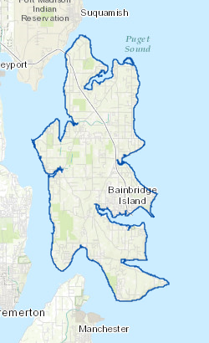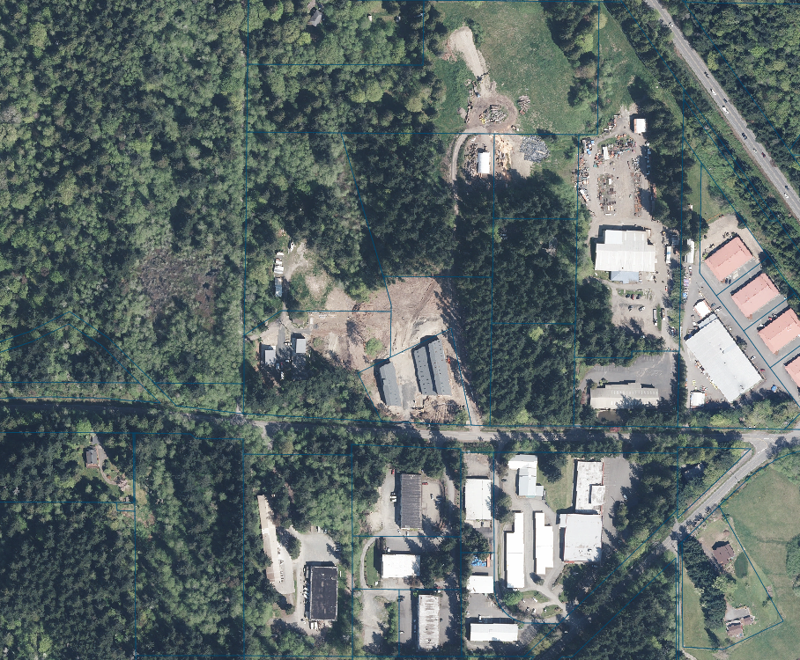

2. TERRAIN: Gentle to moderate sloping to wetland areas with a knoll in the northeastern portion of the site and a mostly flat development area in the southeastern portion of the site.
3. SITE DEVELOPMENT:
The property is undeveloped.

4. ACCESS:
Vehicular access to the site is from a private adjoining road known as Manzanita Park/Saddle Club. A drive connects the site from the south, and emergency access is proposed to utilize this existing drive.

5. PUBLIC SERVICES:
a. Police - Bainbridge Island Police Department.
b. Fire - Bainbridge Island Fire District #23.
c. Schools - Bainbridge Island School District.

6. SURROUNDING USES:
- North: Undeveloped
- East: Undeveloped
- South: Light Manufacturing
- West: Saddle Club Park

7. SURROUNDING ZONING/COMPREHENSIVE PLAN DESIGNATION
a. Subject Parcel: Bainbridge/Industrial
b. North: Bainbridge/Industrial
c. East: Bainbridge/Industrial
d. South: Bainbridge/Industrial
e. West: R-0.4

8. SURROUNDING COMPREHENSIVE PLAN DESIGNATION
a. Subject Parcel: Bainbridge/Industrial
b. North: Bainbridge/Industrial
c. East: Bainbridge/Industrial
d. South: Bainbridge/Industrial.
e. West: OSR-0.4

- History
- On February 17, 2015, the applicant had a pre-application meeting with the City.
- On March 16, 2015, the applicant had a meeting with the Design Review Board.
- On March 16, 2015, the applicant held a public participation meeting at City Hall.
- On October 27, 2015, the Site Plan and Design Review Application was submitted (see reference document 1 -8).
- On December 11, 2015, the project was noticed with the comment period ending on January 4, 2016.
- On January 4, 2016, the application was reviewed by the Design Review Board (reference doc 11).
- On March 1, 2015, the Development Engineer sent correspondence to the applicant (see reference document 10).
- On March 21, 2016, the City informed the applicant of outstanding landscaping requirements based on the City’s Administrative Manual.
- On April 1, 2016, the City wrote the applicant’s agent a letter requesting information and informed the applicant of the increased buffer on the property (see reference document 21).
- On June 2, 2016, the applicant’s agent inquired with the City regarding the possibility of processing the application as a minor site plan review.
- On September 1, 2016, the applicant submitted a revised application reducing the amount of buildings from ten to five (reference doc 14).
- On September 21, 2016, the City contacted the applicant’s agent to let them know there were additional revisions needed to complete the revised application.
- On September 28, 2016, the City informed the applicant’s agent that the Project Planner was on maternity leave and the project had been reassigned to another City Planner.
- On January 17, 2017, the City Project Planner returned from maternity leave.
- On February 15, 2017, the City met with the owner to discuss outstanding items.
- On February 21, 2017, the City sent the owner a letter informing them of outstanding items that needed to be addressed for the City to complete its review of the revised application (reference doc 18).
- On April 17, 2017, the City was contacted by the applicant’s attorney, Christopher Marston (see reference document 15). The letter responded to a request letter sent on February 17, 2017. The letter concluded with a request that the City either approve the Application, deny the Application, in which case it will appeal the decision or agree to proceed with mediation under Bainbridge Island Municipal Code, Section 2.19.
- Between April 25 and April 26, there was clarifying questions between the City and Mr. Marston. Mr. Marston informed the City that it was not his client’s intention to withdraw the request to proceed with the Permit for the 10 buildings. He also stated that the documentation showing only 5 buildings was provided per the City’s recommendation and requested a decision on the Permit for approval of the construction of the 10 buildings (reference doc 20).
- On May 1, 2017 the City responded to Mr. Marston with two options (1) for the City to review the application for 10 buildings and proceed with a recommendation or denial or 2) for the City to proceed with reviewing the revised application for five buildings (reference doc 17).
- On May 4, 2017, Mr. Marston responded and requested that the City review the application for ten buildings (reference doc 16).
- On May 31, 2017, the City contacted Mr. Marston regarding an easement that was not depicted on the site plans to confirm if it existed.
- On June 1, 2017, Mr. Marston confirmed that the easement existed and that it could be vacated (reference doc 19).
- Project Description
The proposal is to construct ten buildings, one of which is a caretaker’s unit on a vacant property. Each proposed building has a footprint of 1,920 square feet and a floor area of 3,192 square feet.
The property abuts a private road that is shared with the Saddle Club. The road is accessible with a 60’ access easement, 30’ of which are on the subject property. Five of the western most buildings are proposed within the 50’ perimeter landscape buffer. A second 50’ access and utility easement exists on the southern border of the property, running east/west. The applicant is proposing to include within that easement area one of the buildings, a landscaping buffer, parking, and drainfields. This easement wasn’t included in the applicant’s proposed site plans. In researching the site, the City discovered the easement and informed the applicant about the existence of the easement. When so informed by the City, the applicant responded by indicating that they would vacate the easement, without specifying how this would be accomplished (reference doc 19).
The property has two wetlands and associated buffers. The site plan does not propose any encroachments into the wetlands and their buffers (reference doc 6). However, stormwater is proposed to discharge to a wetland at the outfall of a replaced culvert proposed to be located opposite the access point along Saddle Club road. The applicant was asked to address the potential impacts on the wetland. This information has not been provided to the City.
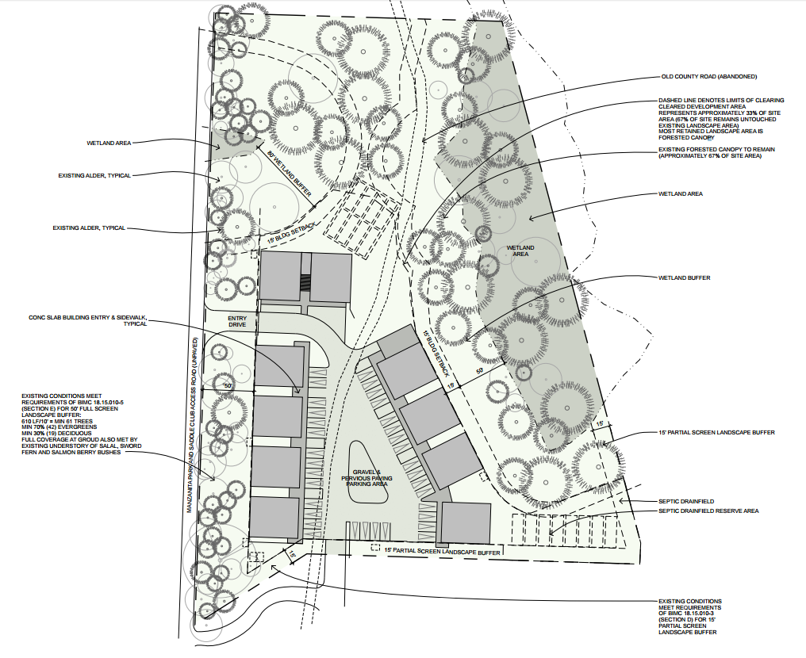
Approximate 50’ easement
Approximate 50’ landscape buffer
Approximate 30’ easement
Approximate 30’

- Requested Revisions to the Original Application
On March 1, 2016, the City’s Development Engineer (see reference document 10) requested information regarding roadway/traffic and stormwater issues. The City requested that the applicant provide a site-specific analysis of the potential impacts of the stormwater on the wetlands. Also, the applicant was asked to conduct a hydrologic analysis of the discharge leaving the site to a wetland at the outfall of the proposed replacement culvert opposite the access point along Saddle Club road.
In addition, pursuant to Kitsap County Board of Health Ordinance 2008-A-01 and the Stormwater Management Manual for Western Washington, the on-site infiltration facilities do not meet the required setbacks from buildings and related to on-site septic (OSS) drainfields and reserves. The applicant was asked to revise the site plan to meet the required facility setbacks.
Furthermore, the applicant was asked to co-design the placement of on-site stormwater infiltration facilities and rain gardens with the landscape plan. As proposed, these facilities would be in required landscape buffers and would adversely affect the function of the buffers.
On April 1, 2016, the City (see reference document 21) requested that the applicant submit information that is required by the Administrative Manual to ensure the long-term survivability of trees required for protection in the 50’ roadside buffer and within the wetland buffer. The information requested was:

- A development site plan identifying size and species of the trees and tree stands, as defined in BIMC 18.15.010.C, heritage trees, or other existing vegetation that are proposed to be retained. The application included a Landscape Plan with trees depicted. It did not include information on the size and species of the trees, with the exception of the alders that were identified.

- The International Society of Arboriculture (ISA) valuation for trees where the critical root zone of a tree required to be retained may be impacted by clearing, grading, construction, development, or maintenance. The Landscape plan did not depict the 30’ easement and the 50’ buffer. The City is unsure what trees may be impacted by development as trees that would be within the 50’ buffer (the 50’ past the 30’) were not included on the landscape plan.

- An analysis prepared by a certified arborist about long-term health and/or viability for trees that will be on the edge of the developed area, and “post development” tree health for trees requested for removal in roadside or perimeter buffers. This analysis should also address protection during construction (see below). This information was also not provided with the application.

- Protection during construction strategies for trees and vegetation to be retained. This information was never submitted by the applicant.

In addition to the information and documentation described above that has not been provided by the applicant, the applicant has failed to revise their plans as requested by the City to meet revised landscaping requirements. The landscape chapter of the City’s Municipal Code was amended after the application was submitted. As a result, the buffer requirements for this type of development increased to a maximum of 50’ and a minimum of 35’. The City requested that the applicant revise their application to provide the 50’ buffer. The applicant submitted their revised application on September 1, 2016. The revision incorrectly showed the buffer beginning from the edge of the 30’ access easement, rather than the property line, which is the correct point of reference. It is noteworthy that the original plans submitted by the applicant incorrectly calculated the buffer from the property line, rather than from the easement.

Given these buffer issues, the City sought clarification from the applicant regarding whether the applicant was continuing to pursue a design that included ten buildings or a design for five buildings. The applicant’s attorney responded on behalf of the applicant and instructed the City to no longer review the application for five buildings and instead review the application that included ten buildings. The applicant was informed by the City it would recommend denial of the ten buildings because the project does not meet the municipal code landscape buffer requirements.
In the preparation of this staff report, comments were received from the City’s surveyor regarding the 30’ easement on the property. While reviewing the easement, the surveyor also noted a 50’ access and utilities easement on the south side of the subject property. This easement was not depicted on any of the drawings submitted by the applicant. The 50’ easement was established in 1991 and was to serve the southern lot and the adjoining lot to the east. The site plan depicts development in this easement area. The City cannot approve the proposed development as depicted because it would impede ingress and egress access to the adjoining property. The project site plan proposes a building, landscaping, a drainfield, and parking within the access easement, which would violate the rights of the easement holder without consent of the current easement holder to abandon this easement.
- Public Comments
The property abuts a private road that is shared with the Saddle Club. During the public participation meeting (see reference document) and the public comment period, concerns were voiced about the safety of the road, the increased use of the road, and the potential impacts on persons riding horses on and near the road (see reference document 12 & 13). To address these concerns, the applicant offered to create a pedestrian trail on their property and to pave the road.
2. BIMC 2.16, Land Use Review Procedures
A. BIMC 2.16.040, Site Plan and Design Review Decision Criteria. The Director and the Planning Commission shall base their respective recommendations or decisions on site plan and design review applications on the following criteria:
1. The site plan and design is in conformance with applicable code provisions and development standards of the applicable zoning district, unless a standard has been modified as a housing design demonstration project pursuant to BIMC 2.16.020.Q. The project is not in conformance with the 50’ perimeter buffer standard in relation to the easement road. As proposed, five of the buildings are proposed within the buffer. In addition, the trees required for protection within the perimeter would not be protected because infiltration trenches are proposed within the buffer.
2. The locations of the buildings and structures, open spaces, landscaping, pedestrian, bicycle and vehicular circulation systems are adequate, safe, efficient and in conformance with the nonmotorized transportation plan. The location of the landscaping is not in conformance with the landscaping requirements of the municipal code (see more detailed analysis below). In addition to the perimeter buffer requirement not being met, the Utility Plan submitted by the applicant depicts infiltration trenches within the landscape buffer. Additionally, the Landscape Plan does not include required parking lot landscaping.
3. The Kitsap County health district has determined that the site plan and design meet the following decision criteria:
a. The proposal conforms to current standards regarding domestic water supply and sewage disposal; or if the proposal is not to be served by public sewers, then the lot has sufficient area and soil, topographic and drainage characteristics to permit an on-site sewage disposal system.
b. If the health district recommends approval of the application with respect to those items in subsection E.3.a of this section, the health district shall so advise the Director.
c. If the health district recommends disapproval of the application, it shall provide a written explanation to the Director. The Health District issued a recommendation of approval on the project (reference doc 9).
4. The city engineer has determined that the site plan and design meets the following decision criteria:
a. The site plan and design conforms to regulations concerning drainage in Chapters 15.20 and 15.21 BIMC; and
b. The site plan and design will not cause an undue burden on the drainage basin or water quality and will not unreasonably interfere with the use and enjoyment of properties downstream; and
c. The streets and pedestrian ways as proposed align with and are otherwise coordinated with streets serving adjacent properties; and
d. The streets and pedestrian ways as proposed are adequate to accommodate anticipated traffic; and
e. If the site will rely on public water or sewer services, there is capacity in the water or sewer system (as applicable) to serve the site, and the applicable service(s) can be made available at the site; and
f. The site plan and design conforms to the “City of Bainbridge Island Engineering Design and Development Standards Manual,” unless the city engineer has approved a variation to the road standards in that document based on his or her determination that the variation meets the purposes of BIMC Title 18. The City’s Development Engineer submitted a letter to the applicant dated March 1, 2016, addressing issues related to roadway/traffic and stormwater, more specifically, the impacts of the stormwater on the wetlands. The applicant was asked to conduct a hydrologic analysis of the discharge leaving the site to a wetland at the outfall of a proposed replacement culvert opposite the access point along Saddle Club road. No analysis was submitted.
In addition, the on-site infiltration facilities fail to meet the required setbacks from buildings and on-site septic (OSS) drainfields and reserves pursuant to Kitsap County Board of Health Ordinance 2008-A-01 and the Stormwater Manual. The City informed the applicant that the facilities need to be revised to meet the required setbacks. The applicant did not submit revisions to address this requirement.
Additionally, the placement of on-site stormwater infiltration facilities and rain gardens needs to be coordinated with the landscape plan. These facilities were proposed in required landscape buffers, which doesn’t comply with the City’s regulations for tree preservation in the buffers.
Absent the information and documentation described above, the City’s Development Engineer cannot confirm that the site plan meets the development criteria for drainage and water quality.
5. The site plan and design is consistent with all applicable design guidelines in BIMC Title 18, unless strict adherence to a guideline has been modified as a housing design demonstration project pursuant to BIMC 2.16.020.Q. The Design Review Board (DRB) found the project to be consistent with the Light Manufacturing design guidelines. The proposed project is subject to the light manufacturing (Business/Industrial) design guidelines. The application was first reviewed by the Design Review Board (“DRB”) on October 1, 2015, during the pre-application conference phase of review (see reference document 11). The DRB made several suggestions at that first meeting and the applicant responded by making several modifications to the design and providing additional screening along the south side of the property.
The DRB again reviewed the proposal after the applicant had resubmitted a revised Site Plan and Design Review Application. The applicant discussed their desire to consolidate their landscaping in the center of their parking lot rather than complying with the municipal code. While sympathetic to this request, the DRB expressed that the parking lot landscaping requirements could not be waived by the DRB. The DRB also noted its concerns that the rain gardens were within the 50’ buffer, and that the landscaping buffer was in the 30’ easement. The DRB approved the application with the following recommendations: 1) Engineer check infiltration with their landscaping architect to ensure buffer requirements can be met; 2) Landscaping in parking area should meet the code; and 3) If there was any change to the buffer, the applicant would return to the DRB.
6. No harmful or unhealthful conditions are likely to result from the proposed site plan. The proposed site plan does not depict a 50’ access and utilities easement on the southern boundary of the property. This easement was recorded as part of a 1991 subdivision and is to serve the abutting properties to the east. As currently designed, proposed building 5, the reserve drainfield area, landscaping, and parking spaces are within the easement area. Construction within an ingress/egress access easement would inhibit access to property it is intended to serve. Based on such a limitation on access and other considerations, what is currently proposed within that easement area would violate the rights of the easement holder. The easement has not been abandoned, and the City would need consent from the current easement holder(s) to abandon this easement.
7. The site plan and design is in conformance with the comprehensive plan and other applicable adopted community plans. The project is in conformance with the Business/Industrial Goals and the Economic Goals of the Comprehensive Plan.
8. Any property subject to site plan and design review that contains a critical area or buffer, as defined in Chapter 16.20 BIMC, conforms to all requirements of that chapter. The site contains wetlands and buffers and appears to meet the requirements of Chapter 16.20 BIMC , but cannot be confirmed to meet Chapter 15.20 absent of the hydrologic analysis of the discharge leaving the site and entering the wetlands. This analysis may trigger mitigation if it found that the outfall discharge for the site exceeds a key threshold (0.1 cfs increase for 100-year outflow).
9. Any property subject to site plan and design review that is within shoreline jurisdiction, as defined in Chapter 16.12 BIMC, conforms to all requirements of that chapter. The site is not located in the shoreline jurisdiction.
10. If the applicant is providing privately owned open space and is requesting credit against dedications for park and recreation facilities required by BIMC 17.20.020.C, the requirements of BIMC 17.20.020.D have been met. The applicant is not providing privately owned open space.
11. The site plan and design has been prepared consistent with the purpose of the site design review process and open space goals. The purpose of the site plan review process is to establish a comprehensive site plan and design review process that ensures compliance with the adopted plans, policies, and ordinances of the City. The site plan has not been prepared consistent with the landscaping and stormwater requirements of the site design review process (BIMC 2.16.040).
12. For applications in the B/I zoning district, the site plan and development proposal include means to integrate and re-use on-site stormwater as site amenities. The site currently provides infiltration in the front yard and roadside buffer. Underground infiltration chambers are not a site amenity, unlike rain gardens.
- BIMC 18.15 Development Standards and Guidelines
- BIMC Section 18.15.010, Landscape Requirements by Zone District: The BI district is subject to the perimeter landscape, roadside buffer and parking lot landscaping requirements.
- Perimeter: B/I to Non-B/I requires a 50’ maximum and a 35’ minimum full screen perimeter buffer. According to BIMC 18.15.010 and the applicable footnote in the table, the perimeter buffer applies even when a private access road separates a B/I property from non-B/I property. The site plan shows a 50’ buffer, but it incorrectly begins at the property line. The correct calculation for the buffer is to establish it from the edge of the 30’ easement.
- Roadside Buffer. B/I to Right-of-Way requires a 50’ maximum and a 35’ minimum full screen road side buffer. The site plan does not show the 50’ roadside buffer from the edge of the easement, but rather incorrectly from the edge of the property.
- Parking Lot Landscaping: Parking lot landscaping is also required; since the parking lot is not adjacent to a public right-of-way; one tree for every eight parking stalls is required. One hundred percent of the trees may be deciduous. Deciduous trees shall have a minimum two-inch caliper and evergreen trees a minimum four feet height at the time of planting. Evergreen ground cover and/or shrubs planted and spaces to achieve total coverage within two years. In addition to the trees, landscaping at the end of the parking aisles is also required. The landscape plan does not depict a partial screen buffer and landscaping at the end of the aisles of the parking lot.
- Total Site Tree Units Requirements: These requirements do not apply to development in the Bainbridge/Industrial land use district.
- Planting Requirements: Planting plans must be prepared or approved by a landscape architect licensed by the State of Washington, a Washington certified nursery professional, or a Washington certified landscaper, and such plans must meet the landscaping submittal requirements of the City’s administrative manual. The plan was not prepared by a landscape architect licensed by the State of Washington, as required by the City’s administrative manual.

III. Conclusions
As proposed, the project fails to comply with the applicable sections of the Bainbridge Island Municipal Code. The application is properly before the Planning Commission for a recommendation to the Director for a decision.
IV. APPEAL
Appeal of an administrative decision may be appealed to the hearing examiner in accordance with BIMC 2.16.130.
V. Reference Documents:
All reference material may be accessed via the City’s Website Online Permit Portal-Smartgov. The following reference materials can be found under the “submittals” and “notes” sections under this file number: PLN50177 SPR

Submittal:
1. Project application received 10/27/2015
2. Project Narrative received 10/27/2015
3. Design Guideline Checklist received 10/27/2015
4. Environmental SEPA Checklist received 10/27/2015
5. Kitsap Public Health District Documentation received 10/27/2015
6. Wetland Report received 10/27/2015
7. Miscellaneous, grading and utility plan (report) received 10/27/2015
8. Plan set received 10/27/2015 received 10/27/2015

Approval Steps:
9. Health District Review
10. Development Engineer Review

Notes:
11. Design Review Board Minutes 1/4/2016, DRB Minutes 010416
12. 50177 Emailed Comment Letter 5/2/2016 RE Creative Spaces Project PLN50177SPR
13. 50177 Comment Letter, 4/29/2016, Creative Spaces Comment Letter (002)
14. 50177 Complete Revision to Site Plans Received, 9/21/2016, 2016_0811_SPR_lettersize
15. Correspondence from Davies Pearson 04202017, 4/20/2017, 50177 SPR Correspondence 041717
16. May 4 Correspondence from Mr. Marston to the City, 5/4/2017, RE PLN50177SPR
17. May 1, 2017 City Response to Mr. Marston, 5/1/2017 May 1, 2017 City Response to Mr. Marston
18. February 21, 2017 letter of outstanding items needed to be address, 2/21/2017, February 21 2017 creative space – outstanding items
19. May 31 and June 1 2017 correspondence regarding the 50’ easement, 5/31/2017, May 31 and June 1 2017 50’ easement correspondence with attorney
20. April 25 to 26th correspondence between City and Attorney, 4/25/2017, April 25 and 26 Correspondence
21. April 1, 2016 request for info correction, 4/1/2016, April 1 2016 request for info.corrections

